CONTENTS
1. DEFINITION OF THE REQUIREMENT 2
2. DEFINITIONS AND ABBREVIATIONS 2
3. REQUIREMENTS RELATED TO THE PROCESS 2
4. ANOMALY / NON-COMPLIANCE 6
5. IDENTIFIED RISKS AND ACTION PLAN 6
6. ARCHIVING 6
7. ELEMENTS TO BE PROVIDED 7

UPDATE HISTORY

VERSION | DATE | PURPOSE
1 | 21/09/2015 | Creation
2 | 14/10/2015 | Modifications
DISTRIBUTION LIST

 |  | AUTHOR | VERIFIED BY | APPROVED BY
STAMP

DEFINITION OF THE REQUIREMENT

Processing service for turnings meant for melting in the PAMCHR.

DEFINITIONS AND ABBREVIATIONS

TURNINGS GENERATORS: companies that generate turnings during their manufacturing process.

TURNINGS COLLECTORS: companies whose business is to collect turnings for eventual melting.

TURNINGS PROCESSORS: companies in charge of preparing the turnings for their melting at the PAMCHR.

PAMCHR: Plasma Arc Melting Cold Hearth Refining

FMECA - Failure Modes and Effects Criticality Analysis: allows identifying and controlling the malfunctions that may occur during the manufacturing process.

TURNINGS BATCH: It is defined by:
- 1 customer,
- 1 contract,
- 1 generation site,
- 1 machining unit / cell,
- 1 generator,
- 1 scrap item,
- 1 pick-up date by a carrier at a collection point,
- 1 processing date,
- 1 processing task list,
- 1 chemical analysis.
One turnings batch, when received by the processor, can be divided into multiple batches during the processing. In certain cases defined by EcoTitanium, multiple collected turnings batches can be mixed during the processing.
One turnings batch may correspond to multiple containers.

TITANIUM ALLOYS (list for information purposes only, not exhaustive): TA6V (grade 5 standard and high O), TA6V ELI, Ti 1023, Ti 5553.

PREMIUM QUALITY TITANIUM: Material produced with special process requirements and quality control, mainly used for the manufacturing of critical rotating parts.

REQUIREMENTS RELATED TO THE PROCESS

The turnings processing set up by the processor must be definite and qualified by EcoTitanium according to a defined qualification plan.
Any change concerning the different stages of the process, as well as the changes made to the technical methods used, must first be validated by EcoTitanium (e.g. task list, key-parameter values, etc.)
Moreover, the requirements related to the turnings processing installations must comply with the requirements of the ISO 9001/14001 repositories in force.

- Inspection/receipt

An inspection/receipt procedure must be provided by the turnings processor and validated by EcoTitanium.

Once the turnings are received, they must be inspected in order to check the compliance of the products with the indications specified on the tracking sheet (grade, gross shipped weight, net weight, etc.) A sample of the turnings batch shall be taken and analysed by the turnings processor. If the batch is not compliant, the processor must inform EcoTitanium, which reserves the right to reject the batch.

- Processing of the turnings

The EcoTitanium requirements related to the processing of turnings are as follows:
- Removal of non-metallic pollutants,
- Removal of fine pollutants and dust,
- Removal of magnetic pollutants,
- Implementation and monitoring of a degreasing procedure with the execution of a C analysis on a representative batch for validation,
- Implementation of a procedure guaranteeing the homogeneity of a batch after mixing,
- Sampling and inspection of the processed batches, with a suitable analytical capacity depending on the grades processed,
- Control of the pollution risk by chaining the processing of different batches,
- Ensuring the traceability, monitoring and marking of the processed turnings batches (procedure documented in support),
- Implementation of a monitoring of the material yield (rate of humidity, fine pollution, magnetic pollution and dust with respect to the volume of turnings on receipt),
- Implementation of a monitoring of the key parameters of the process (defined after the execution of a FMECA by the processor),
- Compliance with the environmental requirements in force before shipping the processed batches,
- Procedure dealing with the management of skills and qualifications of the operators.

After the processing, the turnings must be dry and free of any foreign material (wood, plastics, paper, oil, grease, lubricant, moisture, steel shot, refractory materials, metallic particles with high melting points and a density of greater than or equal to 5, paints, adhesives, etc. - Appendix 1: List of forbidden materials that may come into contact with the turnings during the processing).
The turnings batch must be homogeneous in its chemical composition.

During the processing, a turnings batch may be divided into multiple batches if necessary (e.g. limitations caused by the capacity of the processing line, etc.) (Appendix 2: management of turnings batches).
Multiple turnings batches may be mixed if certain requirements are satisfied (Appendix 2: management of turnings batches):
- Similar chemical analysis,
- Compliance of the different batches to be mixed with respect to the requirements of EcoTitanium,
- Batch size less than the minimum required by the processing line, etc.
In all cases, the mixing of multiple batches must be validated by EcoTitanium.

Any already created batch must retain its traceability.

The turnings processor must be able, at any stage of the process, to provide proof guaranteeing its compliance with the requirements specified in these specifications.

- Special requirements

The equipment used to process the Titanium alloy turnings must be dedicated only to their processing and must be cleaned on changing a grade. Otherwise (in the case of non-dedicated equipment), a cleaning procedure for the equipment must be provided by the turnings processor and validated by EcoTitanium.

As far as possible, the processing line must not comprise TIG welding that can contaminate the turnings. If this requirement cannot be satisfied, the TIG welding must, at least, be checked via X-rays before being used.
If it is necessary to carry out TIG welding close to or on an equipment used for processing Titanium turnings, protection must be implemented against contamination by the welding spray. After the welding operation, the welds must be meticulously cleaned and inspected (at least via X-ray inspection).

- Chemical compositions

Grades | Fe, max | O, max | C, max | N, max | H, max | Al | V
TA6V (Grade 5 standard) | 0.30 | 0.20 | 0.08 | 0.03 | 0.015 | 5.50-6.75 | 3.50-4.50
TA6V (Grade 5 high O) | 0.30 | 0.22 | 0.08 | 0.03 | 0.015 | 5.50-6.75 | 3.50-4.50
TA6V ELI (Grade 23) | 0.25 | 0.13 | 0.08 | 0.03 | 0.012 | 5.50-6.30 | 3.50-4.50
Ti 1023 | 1.80-2.20 | 0.13 | 0.050 | 0.050 | 0.015 | 2.60-3.40 | 9.00-11.00

Grade | Fe | O, max | C, max | N, max | H, max | Al | V | Mo | Cr | Zr, max
Ti 5553 | 0.30-0.50 | 0.18 | 0.100 | 0.050 | 0.015 | 4.40-5.70 | 4.00-5.50 | 4.00-5.50 | 2.50-3.50 | 0.300
(The values given in the above table are expressed in % weight.
The remainder only comprises Titanium).

A certificate of conformity shall be established after the processing. It must mention:
- The results of the chemical analyses conducted on the representative samples of the batch,
- The compliance with this specification,
- A measurement of the density of the turnings batch,
- Tests of radioactivity (radioactivity limit for raw materials accepted by EcoTitanium = 0.36 µSv/h).

- Packaging

The containers to be used shall be plastic crates of 1.30 m x 1.15 m x 1.25 m, closed with a watertight cover that will also help preventing contamination, loss or mixture, and are to be provided exclusively by EcoTitanium. It should be possible to handle them using fork-lift trucks and they must be stackable.
These containers shall be exclusively dedicated to transporting Titanium alloys and, in particular, to the round trips between the processor and EcoTitanium.

Before filling the containers, the turnings processor must ensure that the container used is clean, i.e. free from any foreign objects such as turnings, oil, moisture, dust, etc. (Inspection procedure for containers has to be set up).

The turnings batch shall be identified by a unique batch number, which can be the collected batch number. One batch may comprise several containers. Each turnings container shall be identified by a unique number.

Each batch shall be accompanied with documents containing the following information:
- The customer name and associated contract,
- the order number,
- the processing order number,
- The scrap item,
- the name of the grade,
- the number of containers and their numbers,
- the batch number,
- The name and address of the turnings generator,
- The exact generation site (workshop, machine, if possible),
- The pick-up date from the generator,
- The date of receipt by the processor,
- Type of secondary incoming raw material (secondary raw material nomenclature, appendix II of Article R. 541-8 of the environmental code),
- The name and address of the secondary raw material shipping installation,
- The name and address of the carrier(s), as well as the receipt number mentioned in Article R 541-53 of the environmental code,
- The number of the secondary raw materials tracking sheet(s) (BSD),
- The code of the processing that shall be executed in the installation according to appendices I and II of directive no. 2088/98/EC,
- the total weight,
- the net weight.
This information shall also be sent to the EcoTitanium IT via a RFID chip carried by each container. The RFID chip will identify the associated container and batch.
Information shall be sent to the EcoTitanium IT by a solution that is to be constructed in partnership with the turnings processor.

The trucks used for the transport of the processed turnings shall be covered. The processed turnings shall be transported such that the contents of the truck are protected and secured until the receipt at EcoTitanium.

- Progress plan

The turnings processor will propose the implementation of a progress plan to EcoTitanium.
EcoTitanium will provide the turnings processor with any help that it may require, which shall be jointly defined when reviewing the contract.
Moreover, the turnings processor will annually present a training plan for its staff, as well as proof that the staff working on the installation is authorised.

ANOMALY / NON-COMPLIANCE

If an anomaly is detected by the turnings processor before or during the processing (e.g. analytical discrepancy, mixture of products, etc.) it must inform EcoTitanium of it as soon as possible.
The anomaly must be resolved at the earliest possible with the cooperation of the EcoTitanium departments, the turnings processor and possibly the turnings collector and/or generator (Appendix 3: Table of responsibilities).

IDENTIFIED RISKS AND ACTION PLAN

Identified risk | Action plan
Pollution/mixing during the processing of the turnings | Procedure to control the risks of pollution/ cross contamination at all stages of the processing.  Procedure to guarantee and demonstrate the effectiveness of the processing (sorting, degreasing, etc.).
Loss of traceability | Traceability monitoring procedure to be implemented.
Change of or non-compliance with the processing task list | Procedure to inform EcoTitanium in case a modification or non-compliance identified in the processing task list and pending validation from EcoTitanium.
Malice | Covered containers and truck with canvas cover during the transport.  Securing of the containers during storage and/or the truck during transport.

ARCHIVING

The final sample, as well as the analysis results and associated production records must be preserved and archived for a period of 40 years.

ELEMENTS TO BE PROVIDED

- Certificates of conformity (chemical analyses, material balance, etc.). This document must be referenced with the processing order number and EcoTitanium order number, etc.
- Receiving report,
- Complete details of the processed batch (batch no., grade, etc.),
- All of the required documents specified in the contract,
- A copy of the sample on which the final analyses were conducted.
- …

APPENDIX 1
List of materials forbidden during the processing of turnings

- 100% of the elements present in the turnings batches must be metallic elements (no wood, plastic, cardboard, etc.).
- Radioactive elements (radioactivity limit = 0.36 µSv/h),
- CMR products (refer to INRS Sheet – ED 976),
- Any refractory material,
- Any metallic element with a high melting point (Tmelting > Tmelting Titanium).
- Metallic elements with a melting temperature that is less than or equal to Titanium.

APPENDIX 2
Management of turnings batches

Breaking down a turnings batch
Management of turnings batches
Grouping of batches

APPENDIX 3
Table of responsibilities

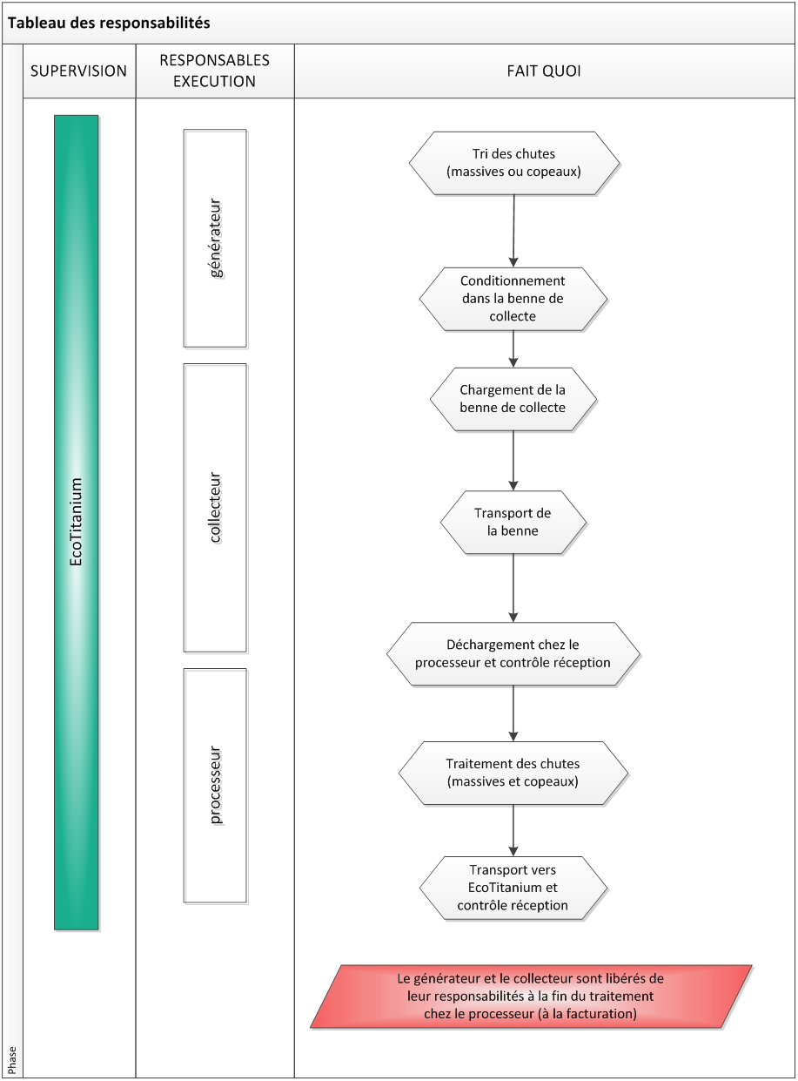
Table of responsibilities
PERSONS IN CHARGE OF EXECUTION
generator
collector
processor
DOES WHAT?
Sorts the scraps (solids or turnings)
Packs them in the collection skip
Loads the collection skip
Transports the skip
Unloads the scraps at the processor and carries out quality inspection at receipt
Conducts the processing of scraps (solids and turnings)
Transports them to EcoTitanium with an inspection at receipt

The generator and the collector are released from their responsibility at the end of the processing by the processor (on invoicing)

