CONTENTS
1. DEFINITION OF THE REQUIREMENT 2
2. DEFINITIONS AND ABBREVIATIONS 2
3. REQUIREMENTS RELATED TO THE PROCESS 2
4. ANOMALY / NON-COMPLIANCE 4
5. IDENTIFIED RISKS AND ACTION PLAN 4
6. ELEMENTS TO BE PROVIDED 5

UPDATE HISTORY

VERSION | DATE | PURPOSE
1 | 16/07/2015 | Creation
2 | 14/10/2015 | Modifications
DISTRIBUTION LIST

 |  | AUTHOR | VERIFIED BY | APPROVED BY
STAMP

DEFINITION OF THE REQUIREMENT

Presentation of the turnings collection process in the turnings generators selected by EcoTitanium.

DEFINITIONS AND ABBREVIATIONS

TURNINGS GENERATORS: companies that generate turnings during their manufacturing process.

TURNINGS COLLECTORS: companies whose business is to collect turnings for eventual melting.

TURNINGS PROCESSORS: companies in charge of preparing the turnings for their melting at the PAMCHR.

COLLECTION CONTAINER: container provided by the turnings collector, which is used to transport the turnings between the turnings generator and the turnings processor.

PAMCHR: Plasma Arc Melting Cold Hearth Refining

TURNINGS BATCH: It is defined by:
- 1 customer,
- 1 contract,
- 1 generation site,
- 1 machining unit / cell,
- 1 generator,
- 1 scrap item,
- 1 pick-up date by a carrier at a collection point.
One turnings batch may correspond to multiple containers.

TITANIUM ALLOYS (list for information purposes only, not exhaustive): TA6V (grade 5 standard and high O), TA6V ELI, Ti 1023, Ti 5553.

REQUIREMENTS RELATED TO THE PROCESS

- Inspection and receipt of the turnings during the pick-up from the turnings generator

An inspection/receipt procedure must be provided by the turnings collector and validated by EcoTitanium.

The turnings collector must ensure that the container used is suitable for collecting EcoTitanium turnings and that the said container is in a good condition.

The turnings collector, jointly with the turnings generator, must ensure that all of the information required for the pick-up has been provided by the turnings generator and must verify the consistency between the information given on the transport order and that on the tracking sheet associated with the batch. It must also inspect the collected products in order to check whether they are compliant with the indications specified on the transport order (type of scrap, etc.).
The turnings collector must inspect the weight of the batch to be loaded (using the method of its choice: truck scale, turnings generator weighing scale, etc.). If there is a discrepancy in the weight announced by the turnings generator, the turnings collector must manage the dispute with the turnings generator before picking up the batch.

- Collection process

- The collector uses a collection plan defined by EcoTitanium to execute a collection.
- The collection plan describes the batch to be collected (Item, grade, quantity, etc.).
- Using this information, the collector should be able to visually identify the batch to be collected from the generator.
- Discrepancies in terms of identification and quantity must be processed between the collector and the generator.
- The turnings collector undertakes to deliver the collected quantity without any risk of mixture/pollution/loss of material. The turnings collector is responsible for verifying the capability of the packaging to comply with this requirement.
- Any non-compliance with the best practices regarding the visual appearance of the provided batch is subject to an alert sent to EcoTitanium, possibly with the transmission of photos of the batches concerned.

- Packaging

The turnings collector will provide the collection containers (unless the generator already possesses containers validated by EcoTitanium).
These containers must be dedicated for the collection and transport of titanium alloys. TIG welding on these containers is forbidden, as well as nitride, oxide or ceramic coatings. MIG, MAG and other forms of welding are allowed. (Appendix 1: List of forbidden materials that may come into contact with the turnings during the collection).

The turnings collector must ensure that the container was covered by the turnings generator for storage. It must ensure that the container remains covered during the transport so as to prevent any risk of pollution.
The collector must pack and ship the containers such that the contents are protected and secured until the delivery.

The turnings batch shall be identified by a unique batch number that is specific to it. One batch may comprise several containers. Each turnings container shall be identified by the batch number.

Each batch shall be accompanied with documents containing the following information:
- The customer name and associated contract,
- the pick-up number,
- The scrap item,
- the name of the grade,
- the number of containers,
- the batch number,
- The name and address of the turnings generator,
- The exact generation site (workshop, machine, if possible),
- The pick-up date and unloading date,
- Type of transported or collected waste (waste nomenclature, appendix II of Article R.541-8 of the environmental code)
- the total weight (information co-signed by the collector and generator),
- the net weight (information co-signed by the collector and generator),
- the total weight (information co-signed by the collector and processor),
- the net weight (information co-signed by the collector and processor),
- the name and address of the receiving installation.

The turnings collector must be able, at any stage of the collection, to provide proof guaranteeing its compliance with the requirements specified in these specifications.

ANOMALY / NON-COMPLIANCE

If an anomaly is detected by the turnings collector before or during the transport (e.g. incident, etc.) it must inform EcoTitanium of it as soon as possible.
Any additional cost over the processing price of the turnings processor that can be attributed to an anomaly related to the non-compliance with the requirements specified in these specifications shall be invoiced to the turnings collector.
The anomaly must be resolved at the earliest possible with the cooperation of the EcoTitanium departments, the turnings collector and/or the generator (Appendix 2: Table of responsibilities).

IDENTIFIED RISKS AND ACTION PLAN

Identified risk | Action plan
Pollution and/or mixing of turnings during loading or transport | Audit of the practices of the collector with training pertaining to the risks related to pollution.
Loss of traceability | Inspection/receipt procedure to be implemented.  Traceability monitoring procedure to be implemented.
Wrong container picked up | Training related to container pick-up risks.
Climatic conditions / malice | Covered containers and truck with canvas cover  Securing of the contents of the truck during transport.

The collector must have a suitable quality system capable of ensuring a reliable level of service and quality.
EcoTitanium may conduct audits of the collector at a frequency deemed appropriate by EcoTitanium.

ELEMENTS TO BE PROVIDED

By EcoTitanium to the turnings collector:
- Collection order.

By the collector to EcoTitanium:
For each collection order:
  - Information required for the execution of the collection operation, to be entered in the ad hoc system validated by EcoTitanium.
  - Receiving slip,
  - Delivery order,
  - Weight ticket,
  - …
To be sent using IT media.

APPENDIX 1
List of materials forbidden during the collection of turnings

- 100% of the elements present in the turnings batches must be metallic elements (no wood, plastic, cardboard, etc.).
- Radioactive elements (radioactivity limit = 0.36 µSv/h),
- CMR products (refer to INRS Sheet – ED 976),
- Any refractory material,
- Any metallic element with a high melting point (Tmelting > Tmelting Titanium).

APPENDIX 2
Table of responsibilities

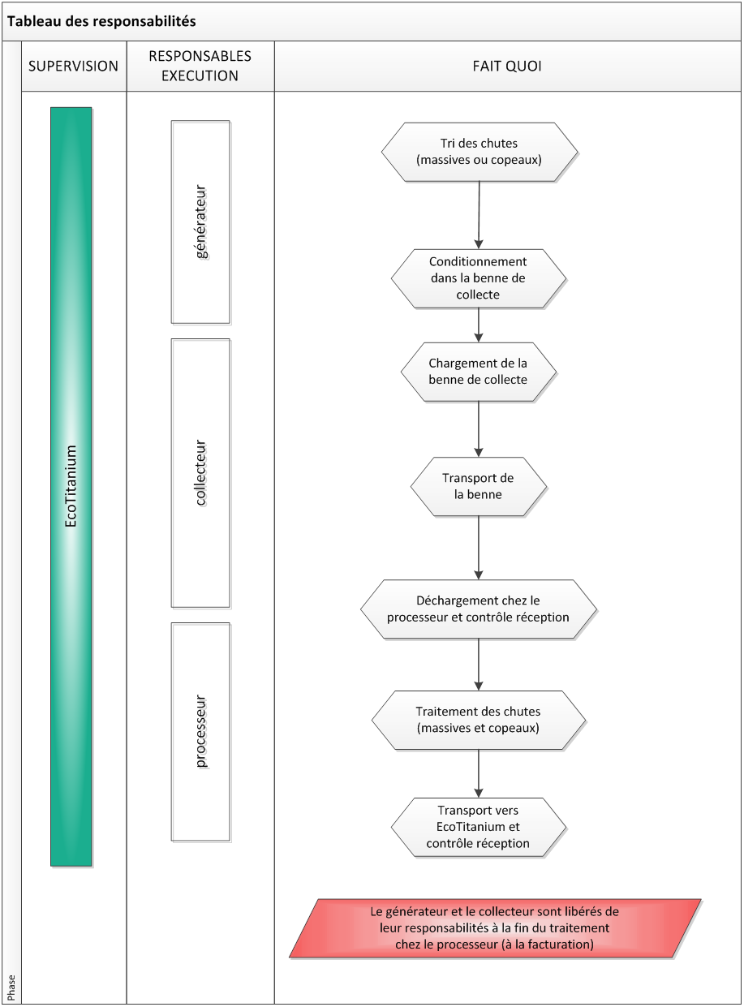
Table of responsibilities
PERSONS IN CHARGE OF EXECUTION
generator
collector
processor
DOES WHAT?
Sorts the scraps (solids or turnings)
Packs them in the collection skip
Loads the collection skip
Transports the skip
Unloads the scraps at the processor and carries out quality inspection at receipt
Conducts the processing of scraps (solids and turnings)
Transports them to EcoTitanium with an inspection at receipt
The generator and the collector are released from their responsibility at the end of the processing by the processor (on invoicing)

